TRACING THE GROWTH OF THE GLOBAL COMMUNITY :A POPULATION FORECASTING ANALYSIS

1.INTRODUCTION

Population forecasting analysis typically involves the use of statistical models to project changes in population size, age structure, and composition. These models can be based on historical data, as well as contemporary demographic, economic, and social trends. By incorporating these factors, population forecasters can make informed predictions about the future size and composition of a population.

Population forecasting analysis is an essential part of effective planning for the long-term well-being of communities and individuals. By understanding the likely future size and composition of populations, policymakers can make better decisions about the allocation of resources and services.

1.1 OVERVIEW

Forecasting population trends is important for planning purposes, as it helps policymakers make informed decisions about issues such as housing, education, health care, and other public services. Understanding future population dynamics also helps businesses, investors, and researchers make informed decisions about where to locate, invest, or conduct research.

The goal of population forecasting is to predict future population size, composition, and spatial distribution for a given area. Different methods can be used to forecast population, including statistical modeling, time series analysis, and demographic simulation.

1.2 PURPOSE

Population forecasting is important for policymakers, planners, and businesses because it helps them to anticipate and prepare for changes in demand for resources, infrastructure, and services. It is also essential for understanding the potential impacts of population growth on the environment and for tracking progress toward global goals such as the United Nations' Sustainable Development Goals.

Overall, population forecasting analysis is a sophisticated and essential tool for anticipating and planning for changes in the size and composition of populations. By better understanding the drivers of population growth or decline, policymakers and other stakeholders can make informed decisions about resource allocation and ensure that the needs of communities are met now and in the future.

PROBLEM DEFINITON & DESIGN THINKING

2.1 EMPATHY MAP

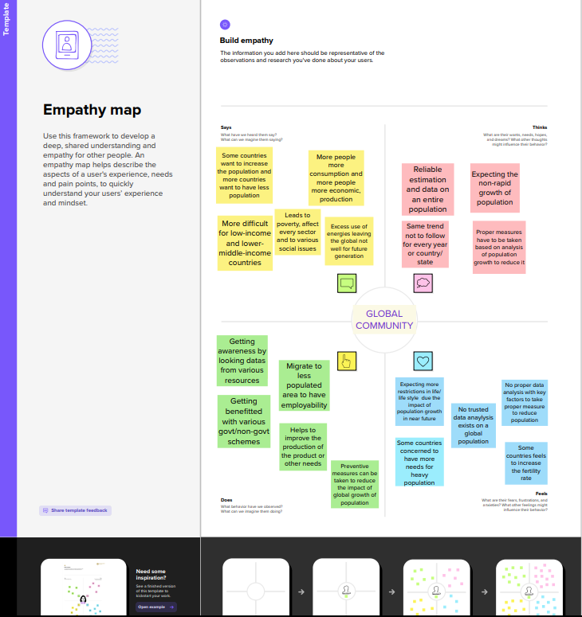

2.2 BRAINSTROM

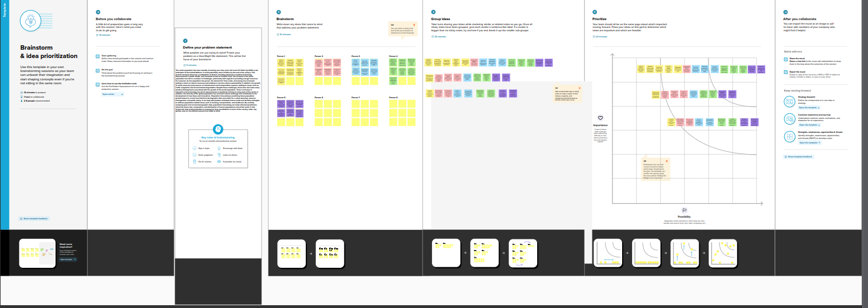

3.RESULT

1.Dashboard

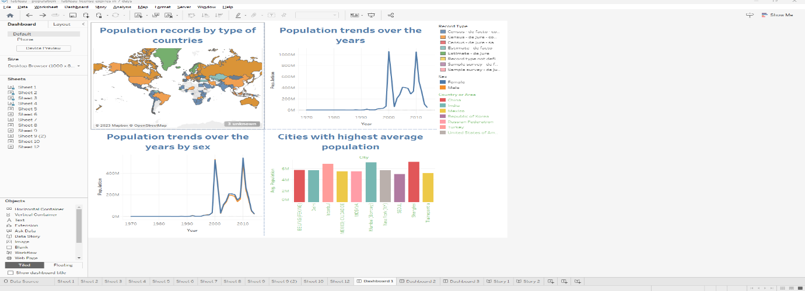

2.web integration

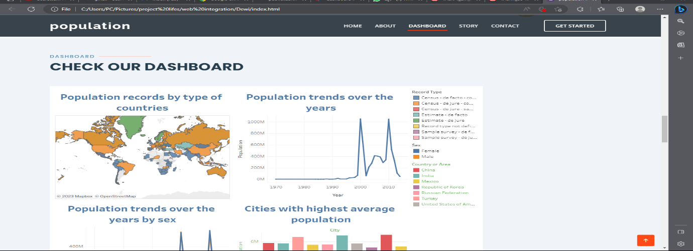

3.story

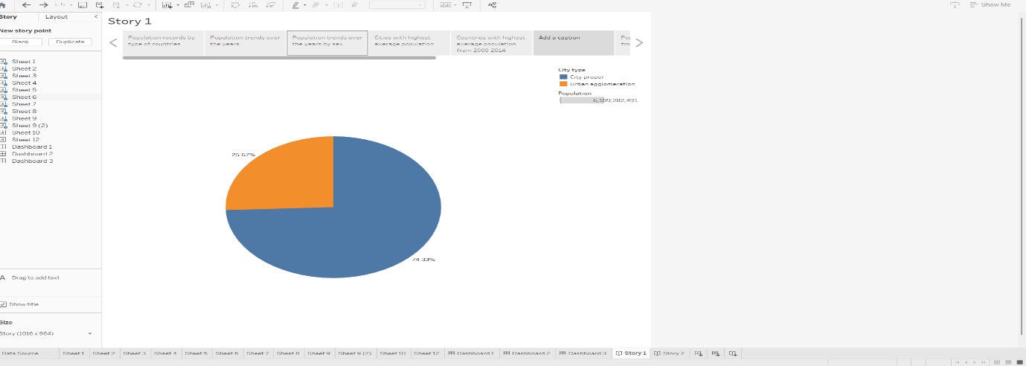

4.ADVANTAGES AND DISADVANTAGES

ADVANTAGES

1. Helps in planning: Provides population forecast analysis for planners and.

Planners based on forecasting changes in demographics and demographics

essay. Eten and health care, .

education, housing, and transportation.

2. Facilitates resource management: it gives a better sense of the future

Population trends, population forecast analysis helps policy makers allocate

more efficient and effective use of resources.

3. Enhances policy making: Demographic predictive analytics can provide insights

In the socio-economic and environmental effects of demographic change. this

Information can help policymakers create policies that are more aligned with policies

the needs and expectations of their constituents.

4. Helps economic growth: Demographic predictive analytics can help businesses

and governments to identify emerging markets and opportunities. It can also be helpful

To understand the potential impact of demographic changes on consumer needs.

DISADVANTAGES

1. Uncertainty: Population forecasting research is based on forward-looking assumptions

Population continuity. Unexpected events, e.g.

changes in immigration policy or natural disasters.

2. Data Limitations: Population prediction analysis is only as accurate as the data

It depends on the story. In some cases, data may be limited, incomplete or out of date, causing it

It is difficult to make accurate predictions.

3. Lack of insight: Population prediction research can be complex and complex

understand. This can be a challenge for policymakers and the public

In order to test it.

5.APPLICATION

Population prediction analytics has many different applications in different industries.

Major application areas of population predictive analytics include:

1. Urban Planning: Demographic predictive analysis is an important tool for urban planners

To understand how it will affect future population growth that was predicted and built

environment. This information can be used to plan important future projects,

including transportation, housing and public services.

2. Health: Population predictive analyzes are used to predict the future in terms of health

medical requirements and how to plan for future health care needs.

It predicts demand for hospitals, clinics and healthcare

Hardworking employees.

3. Education: Population prediction research is used in education to predict the future

enrolling students and planning for future school and college system needs. this

Includes forecasts of demand for classrooms, teachers, and educational resources.

4. Employment and Economics: Demographic forecast analysis and industry and.

governments do not forecast future consumer needs and plan for future economies

growth. This includes forecasting demand for goods and services and forecasting workforce

dynamics, and identification of emerging markets and opportunities.

5. Environmental management: Population prediction analysis is applied to the environment

Staff foreseeing future demand and planning for the future

Environmental policy requirements. This includes water demand forecasting, .

energy and waste management facilities.

6.CONCLUSION

Ever since the dawn of the humankind, there are estimated over 105 Billion people who walked on this planet. 8 billion of them are alive right now. India is the most populated country in the world right now. Since the rate of birth is higher than the rate of death, the population is always increasing. Since the 1900’s the field of medicines grew very large and it played a major role in the higher life expectancy of humans. The population is expected to hit 9.8 billion by 2050. IT can be negative or positive depending on various circumstances. For a country with large population, it would be great for the country economic develelopment. ON the negative side they have inadequate on food, clothing and house etc.

7.FUTURE SCOPE

Population prediction research has always been and continues to be an evolving field of research

key to his future success. Some areas of population forecast

The survey is expected to increase in the future to:

1. Addition of new data sources: Currently based on population prediction analysis

In data such as birth rates, death rates, and types of migration. However, the future

Other sources of data include social media, mobile phone usage and satellite imagery

can be added to provide a general understanding of the population

Transportation of goods everywhere.

2. Machine Learning and Artificial Intelligence: Improving Machine Learning and.

Artificial intelligence can help improve the accuracy of population forecasting

The best of the best. A lot of information can be analyzed and discovered using this technology

patterns and trends that would otherwise be difficult or impossible to detect manually.

3. Interactions with other fields: Can be integrated with population prediction research

Other areas such as urban planning, public health, and environmental science to

provides a more complete understanding of population growth and its effects.

4. Predicting climate change impacts: Climate change is anticipated

The main effects of population growth, including changes in migration, .

epidemic diseases and access to resources. Demographic predictive analysis can help

To support policies and strategies to anticipate these outcomes.

Deal with them.

5. Addressing ethical concerns: Population prediction research raises ethical concerns

covering issues such as population control, resource allocation, and equity. future

Research can address these concerns and focus on developing ethical guidelines

8.APPENDIX

SOURCE CODE

<!DOCTYPE html>

<html lang="en">

<head>

<meta charset="utf-8">

<meta content="width=device-width, initial-scale=1.0" name="viewport">

<title>population Bootstrap Template - Index</title>

<meta content="" name="description">

<meta content="" name="keywords">

<!-- Favicons -->

<link href="assets/img/favicon.png" rel="icon">

<link href="assets/img/apple-touch-icon.png" rel="apple-touch-icon">

<!-- Google Fonts -->

<link href="https://fonts.googleapis.com/css?family=Open+Sans:300,300i,400,400i,600,600i,700,700i|Raleway:300,300i,400,400i,500,500i,600,600i,700,700i|Poppins:300,300i,400,400i,500,500i,600,600i,700,700i" rel="stylesheet">

<!-- Vendor CSS Files -->

<link href="assets/vendor/aos/aos.css" rel="stylesheet">

<link href="assets/vendor/bootstrap/css/bootstrap.min.css" rel="stylesheet">

<link href="assets/vendor/bootstrap-icons/bootstrap-icons.css" rel="stylesheet">

<link href="assets/vendor/boxicons/css/boxicons.min.css" rel="stylesheet">

<link href="assets/vendor/glightbox/css/glightbox.min.css" rel="stylesheet">

<link href="assets/vendor/remixicon/remixicon.css" rel="stylesheet">

<link href="assets/vendor/swiper/swiper-bundle.min.css" rel="stylesheet">

<!-- Template Main CSS File -->

<link href="assets/css/style.css" rel="stylesheet">

<!-- =======================================================

* Template Name: population

* Updated: Mar 10 2023 with Bootstrap v5.2.3

* Template URL: https://bootstrapmade.com/population-free-multi-purpose-html-template/

* Author: BootstrapMade.com

* License: https://bootstrapmade.com/license/

======================================================== -->

</head>

<body>

<!-- ======= Header ======= -->

<header id="header" class="fixed-top ">

<div class="container d-flex align-items-center justify-content-between">

<h1 class="logo"><a href="index.html">population</a></h1>

<!-- Uncomment below if you prefer to use an image logo -->

<!-- <a href="index.html" class="logo"><img src="assets/img/logo.png" alt="" class="img-fluid"></a>-->

<nav id="navbar" class="navbar">

<ul>

<li><a class="nav-link scrollto active" href="#hero">Home</a></li>

<li><a class="nav-link scrollto" href="#about">About</a></li>

<li><a class="nav-link scrollto" href="#Dashboard">Dashboard</a></li>

<li><a class="nav-link scrollto " href="#Story">Story</a></li>

<li><a class="nav-link scrollto" href="#contact">Contact</a></li>

<li><a class="getstarted scrollto" href="#about">Get Started</a></li>

</ul>

<i class="bi bi-list mobile-nav-toggle"></i>

</nav><!-- .navbar -->

</div>

</header><!-- End Header -->

<!-- ======= Hero Section ======= -->

<section id="hero">

<div class="hero-container" data-aos="fade-up" data-aos-delay="150">

<h1>ana.</h1>

<h2>tracing the growth of population</h2>

<div class="d-flex">

<a href="#about" class="btn-get-started scrollto">Get Started</a>

<a href="https://www.youtube.com/watch?v=jDDaplaOz7Q" class="glightbox btn-watch-video"><i class="bi bi-play-circle"></i><span>Watch Video</span></a>

</div>

</div>

</section><!-- End Hero -->

<main id="main">

<!-- ======= About Section ======= -->

<section id="about" class="about">

<div class="container" data-aos="fade-up">

<div class="row justify-content-end">

<div class="col-lg-11">

<div class="row justify-content-end">

<div class="col-lg-3 col-md-5 col-6 d-md-flex align-items-md-stretch">

<div class="count-box">

<i class="bi bi-emoji-smile"></i>

<span data-purecounter-start="0" data-purecounter-end="125" data-purecounter-duration="1" class="purecounter"></span>

<p>Happy Clients</p>

</div>

</div>

<div class="col-lg-3 col-md-5 col-6 d-md-flex align-items-md-stretch">

<div class="count-box">

<i class="bi bi-journal-richtext"></i>

<span data-purecounter-start="0" data-purecounter-end="85" data-purecounter-duration="1" class="purecounter"></span>

<p>Projects</p>

</div>

</div>

<div class="col-lg-3 col-md-5 col-6 d-md-flex align-items-md-stretch">

<div class="count-box">

<i class="bi bi-clock"></i>

<span data-purecounter-start="0" data-purecounter-end="35" data-purecounter-duration="1" class="purecounter"></span>

<p>Years of experience</p>

</div>

</div>

<div class="col-lg-3 col-md-5 col-6 d-md-flex align-items-md-stretch">

<div class="count-box">

<i class="bi bi-award"></i>

<span data-purecounter-start="0" data-purecounter-end="48" data-purecounter-duration="1" class="purecounter"></span>

<p>Awards</p>

</div>

</div>

</div>

</div>

</div>

<div class="row">

<div class="col-lg-6 video-box align-self-baseline" data-aos="zoom-in" data-aos-delay="100">

<img src="assets/img/about.jpg" class="img-fluid" alt="">

<a href="https://www.youtube.com/watch?v=jDDaplaOz7Q" class="glightbox play-btn mb-4"></a>

</div>

<div class="col-lg-6 pt-3 pt-lg-0 content">

<h3>Voluptatem dignissimos provident quasi corporis voluptates sit assumenda.</h3>

<p class="fst-italic">

Lorem ipsum dolor sit amet, consectetur adipiscing elit, sed do eiusmod tempor incididunt ut labore et dolore

magna aliqua.

</p>

<ul>

<li><i class="bx bx-check-double"></i> Ullamco laboris nisi ut aliquip ex ea commodo consequat.</li>

<li><i class="bx bx-check-double"></i> Duis aute irure dolor in reprehenderit in voluptate velit.</li>

<li><i class="bx bx-check-double"></i> Voluptate repellendus pariatur reprehenderit corporis sint.</li>

<li><i class="bx bx-check-double"></i> Ullamco laboris nisi ut aliquip ex ea commodo consequat. Duis aute irure dolor in reprehenderit in voluptate trideta storacalaperda mastiro dolore eu fugiat nulla pariatur.</li>

</ul>

<p>

Ullamco laboris nisi ut aliquip ex ea commodo consequat. Duis aute irure dolor in reprehenderit in voluptate

velit esse cillum dolore eu fugiat nulla pariatur. Excepteur sint occaecat cupidatat non proident, sunt in

culpa qui officia deserunt mollit anim id est laborum

</p>

</div>

</div>

</div>

</section><!-- End About Section -->

<!-- ======= About Boxes Section ======= -->

<section id="about-boxes" class="about-boxes">

<div class="container" data-aos="fade-up">

<div class="row">

<div class="col-lg-4 col-md-6 d-flex align-items-stretch" data-aos="fade-up" data-aos-delay="100">

<div class="card">

<img src="assets/img/about-boxes-1.jpg" class="card-img-top" alt="...">

<div class="card-icon">

<i class="ri-brush-4-line"></i>

</div>

<div class="card-body">

<h5 class="card-title"><a href="">Our Mission</a></h5>

<p class="card-text">Lorem ipsum dolor sit amet, consectetur elit, sed do eiusmod tempor ut labore et dolore magna aliqua. Ut enim ad minim veniam, quis nostrud exercitation ullamco laboris nisi ut aliquip ex ea commodo consequat. </p>

</div>

</div>

</div>

<div class="col-lg-4 col-md-6 d-flex align-items-stretch" data-aos="fade-up" data-aos-delay="200">

<div class="card">

<img src="assets/img/about-boxes-2.jpg" class="card-img-top" alt="...">

<div class="card-icon">

<i class="ri-calendar-check-line"></i>

</div>

<div class="card-body">

<h5 class="card-title"><a href="">Our Plan</a></h5>

<p class="card-text">Sed ut perspiciatis unde omnis iste natus error sit voluptatem doloremque laudantium, totam rem aperiam, eaque ipsa quae ab illo inventore veritatis et quasi architecto beatae vitae dicta sunt explicabo. </p>

</div>

</div>

</div>

<div class="col-lg-4 col-md-6 d-flex align-items-stretch" data-aos="fade-up" data-aos-delay="300">

<div class="card">

<img src="assets/img/about-boxes-3.jpg" class="card-img-top" alt="...">

<div class="card-icon">

<i class="ri-movie-2-line"></i>

</div>

<div class="card-body">

<h5 class="card-title"><a href="">Our Vision</a></h5>

<p class="card-text">Nemo enim ipsam voluptatem quia voluptas sit aut odit aut fugit, sed quia magni dolores eos qui ratione voluptatem sequi nesciunt Neque porro quisquam est, qui dolorem ipsum quia dolor sit amet. </p>

</div>

</div>

</div>

</div>

</div>

</section><!-- End About Boxes Section -->

<!-- ======= Clients Section ======= -->

<section id="clients" class="clients">

<div class="container" data-aos="zoom-in">

<div class="row">

<div class="col-lg-2 col-md-4 col-6 d-flex align-items-center justify-content-center">

<img src="assets/img/clients/client-1.png" class="img-fluid" alt="">

</div>

<div class="col-lg-2 col-md-4 col-6 d-flex align-items-center justify-content-center">

<img src="assets/img/clients/client-2.png" class="img-fluid" alt="">

</div>

<div class="col-lg-2 col-md-4 col-6 d-flex align-items-center justify-content-center">

<img src="assets/img/clients/client-3.png" class="img-fluid" alt="">

</div>

<div class="col-lg-2 col-md-4 col-6 d-flex align-items-center justify-content-center">

<img src="assets/img/clients/client-4.png" class="img-fluid" alt="">

</div>

<div class="col-lg-2 col-md-4 col-6 d-flex align-items-center justify-content-center">

<img src="assets/img/clients/client-5.png" class="img-fluid" alt="">

</div>

<div class="col-lg-2 col-md-4 col-6 d-flex align-items-center justify-content-center">

<img src="assets/img/clients/client-6.png" class="img-fluid" alt="">

</div>

</div>

</div>

</section><!-- End Clients Section -->

<!-- ======= Features Section ======= -->

<section id="features" class="features">

<div class="container" data-aos="fade-up">

<ul class="nav nav-tabs row d-flex">

<li class="nav-item col-3">

<a class="nav-link active show" data-bs-toggle="tab" href="#tab-1">

<i class="ri-gps-line"></i>

<h4 class="d-none d-lg-block">Modi sit est dela pireda nest</h4>

</a>

</li>

<li class="nav-item col-3">

<a class="nav-link" data-bs-toggle="tab" href="#tab-2">

<i class="ri-body-scan-line"></i>

<h4 class="d-none d-lg-block">Unde praesenti mara setra le</h4>

</a>

</li>

<li class="nav-item col-3">

<a class="nav-link" data-bs-toggle="tab" href="#tab-3">

<i class="ri-sun-line"></i>

<h4 class="d-none d-lg-block">Pariatur explica nitro dela</h4>

</a>

</li>

<li class="nav-item col-3">

<a class="nav-link" data-bs-toggle="tab" href="#tab-4">

<i class="ri-store-line"></i>

<h4 class="d-none d-lg-block">Nostrum qui dile node</h4>

</a>

</li>

</ul>

<div class="tab-content">

<div class="tab-pane active show" id="tab-1">

<div class="row">

<div class="col-lg-6 order-2 order-lg-1 mt-3 mt-lg-0">

<h3>Voluptatem dignissimos provident quasi corporis voluptates sit assumenda.</h3>

<p class="fst-italic">

Lorem ipsum dolor sit amet, consectetur adipiscing elit, sed do eiusmod tempor incididunt ut labore et dolore

magna aliqua.

</p>

<ul>

<li><i class="ri-check-double-line"></i> Ullamco laboris nisi ut aliquip ex ea commodo consequat.</li>

<li><i class="ri-check-double-line"></i> Duis aute irure dolor in reprehenderit in voluptate velit.</li>

<li><i class="ri-check-double-line"></i> Ullamco laboris nisi ut aliquip ex ea commodo consequat. Duis aute irure dolor in reprehenderit in voluptate trideta storacalaperda mastiro dolore eu fugiat nulla pariatur.</li>

</ul>

<p>

Ullamco laboris nisi ut aliquip ex ea commodo consequat. Duis aute irure dolor in reprehenderit in voluptate

velit esse cillum dolore eu fugiat nulla pariatur. Excepteur sint occaecat cupidatat non proident, sunt in

culpa qui officia deserunt mollit anim id est laborum

</p>

</div>

<div class="col-lg-6 order-1 order-lg-2 text-center">

<img src="assets/img/features-1.png" alt="" class="img-fluid">

</div>

</div>

</div>

<div class="tab-pane" id="tab-2">

<div class="row">

<div class="col-lg-6 order-2 order-lg-1 mt-3 mt-lg-0">

<h3>Neque exercitationem debitis soluta quos debitis quo mollitia officia est</h3>

<p>

Ullamco laboris nisi ut aliquip ex ea commodo consequat. Duis aute irure dolor in reprehenderit in voluptate

velit esse cillum dolore eu fugiat nulla pariatur. Excepteur sint occaecat cupidatat non proident, sunt in

culpa qui officia deserunt mollit anim id est laborum

</p>

<p class="fst-italic">

Lorem ipsum dolor sit amet, consectetur adipiscing elit, sed do eiusmod tempor incididunt ut labore et dolore

magna aliqua.

</p>

<ul>

<li><i class="ri-check-double-line"></i> Ullamco laboris nisi ut aliquip ex ea commodo consequat.</li>

<li><i class="ri-check-double-line"></i> Duis aute irure dolor in reprehenderit in voluptate velit.</li>

<li><i class="ri-check-double-line"></i> Provident mollitia neque rerum asperiores dolores quos qui a. Ipsum neque dolor voluptate nisi sed.</li>

<li><i class="ri-check-double-line"></i> Ullamco laboris nisi ut aliquip ex ea commodo consequat. Duis aute irure dolor in reprehenderit in voluptate trideta storacalaperda mastiro dolore eu fugiat nulla pariatur.</li>

</ul>

</div>

<div class="col-lg-6 order-1 order-lg-2 text-center">

<img src="assets/img/features-2.png" alt="" class="img-fluid">

</div>

</div>

</div>

<div class="tab-pane" id="tab-3">

<div class="row">

<div class="col-lg-6 order-2 order-lg-1 mt-3 mt-lg-0">

<h3>Voluptatibus commodi ut accusamus ea repudiandae ut autem dolor ut assumenda</h3>

<p>

Ullamco laboris nisi ut aliquip ex ea commodo consequat. Duis aute irure dolor in reprehenderit in voluptate

velit esse cillum dolore eu fugiat nulla pariatur. Excepteur sint occaecat cupidatat non proident, sunt in

culpa qui officia deserunt mollit anim id est laborum

</p>

<ul>

<li><i class="ri-check-double-line"></i> Ullamco laboris nisi ut aliquip ex ea commodo consequat.</li>

<li><i class="ri-check-double-line"></i> Duis aute irure dolor in reprehenderit in voluptate velit.</li>

<li><i class="ri-check-double-line"></i> Provident mollitia neque rerum asperiores dolores quos qui a. Ipsum neque dolor voluptate nisi sed.</li>

</ul>

<p class="fst-italic">

Lorem ipsum dolor sit amet, consectetur adipiscing elit, sed do eiusmod tempor incididunt ut labore et dolore

magna aliqua.

</p>

</div>

<div class="col-lg-6 order-1 order-lg-2 text-center">

<img src="assets/img/features-3.png" alt="" class="img-fluid">

</div>

</div>

</div>

<div class="tab-pane" id="tab-4">

<div class="row">

<div class="col-lg-6 order-2 order-lg-1 mt-3 mt-lg-0">

<h3>Omnis fugiat ea explicabo sunt dolorum asperiores sequi inventore rerum</h3>

<p>

Ullamco laboris nisi ut aliquip ex ea commodo consequat. Duis aute irure dolor in reprehenderit in voluptate

velit esse cillum dolore eu fugiat nulla pariatur. Excepteur sint occaecat cupidatat non proident, sunt in

culpa qui officia deserunt mollit anim id est laborum

</p>

<p class="fst-italic">

Lorem ipsum dolor sit amet, consectetur adipiscing elit, sed do eiusmod tempor incididunt ut labore et dolore

magna aliqua.

</p>

<ul>

<li><i class="ri-check-double-line"></i> Ullamco laboris nisi ut aliquip ex ea commodo consequat.</li>

<li><i class="ri-check-double-line"></i> Duis aute irure dolor in reprehenderit in voluptate velit.</li>

<li><i class="ri-check-double-line"></i> Ullamco laboris nisi ut aliquip ex ea commodo consequat. Duis aute irure dolor in reprehenderit in voluptate trideta storacalaperda mastiro dolore eu fugiat nulla pariatur.</li>

</ul>

</div>

<div class="col-lg-6 order-1 order-lg-2 text-center">

<img src="assets/img/features-4.png" alt="" class="img-fluid">

</div>

</div>

</div>

</div>

</div>

</section><!-- End Features Section -->

<!-- ======= Dashboard Section ======= -->

<section id="Dashboard" class="Dashboard section-bg">

<div class="container" data-aos="fade-up">

<div class="section-title">

<h2>Dashboard</h2>

<p>Check our Dashboard</p>

</div>

<div class='tableauPlaceholder' id='viz1681121884799' style='position: relative'><noscript><a href='#'><img alt='Dashboard 1 ' src='https:&#47;&#47;public.tableau.com&#47;static&#47;images&#47;da&#47;dashboard1_16811195230140&#47;Dashboard1&#47;1_rss.png' style='border: none' /></a></noscript><object class='tableauViz' style='display:none;'><param name='host_url' value='https%3A%2F%2Fpublic.tableau.com%2F' /> <param name='embed_code_version' value='3' /> <param name='site_root' value='' /><param name='name' value='dashboard1_16811195230140&#47;Dashboard1' /><param name='tabs' value='no' /><param name='toolbar' value='yes' /><param name='static_image' value='https:&#47;&#47;public.tableau.com&#47;static&#47;images&#47;da&#47;dashboard1_16811195230140&#47;Dashboard1&#47;1.png' /> <param name='animate_transition' value='yes' /><param name='display_static_image' value='yes' /><param name='display_spinner' value='yes' /><param name='display_overlay' value='yes' /><param name='display_count' value='yes' /><param name='language' value='en-US' /><param name='filter' value='publish=yes' /></object></div> <script type='text/javascript'> var divElement = document.getElementById('viz1681121884799'); var vizElement = divElement.getElementsByTagName('object')[0]; if ( divElement.offsetWidth > 800 ) { vizElement.style.width='1000px';vizElement.style.height='827px';} else if ( divElement.offsetWidth > 500 ) { vizElement.style.width='1000px';vizElement.style.height='827px';} else { vizElement.style.width='100%';vizElement.style.height='1427px';} var scriptElement = document.createElement('script'); scriptElement.src = 'https://public.tableau.com/javascripts/api/viz_v1.js'; vizElement.parentNode.insertBefore(scriptElement, vizElement); </script>

</div>

</section><!-- End Dashboard Section -->

<!-- ======= Story Section ======= -->

<section id="Story" class="Story">

<div class="container" data-aos="fade-up">

<div class="section-title">

<h2>Story</h2>

<p>Check our Story</p>

</div>

<div class='tableauPlaceholder' id='viz1681121987818' style='position: relative'><noscript><a href='#'><img alt='TRACING THE GROWTH OF GLOBAL POPULATION ' src='https:&#47;&#47;public.tableau.com&#47;static&#47;images&#47;po&#47;populationstory_16811165501610&#47;Story1&#47;1_rss.png' style='border: none' /></a></noscript><object class='tableauViz' style='display:none;'><param name='host_url' value='https%3A%2F%2Fpublic.tableau.com%2F' /> <param name='embed_code_version' value='3' /> <param name='site_root' value='' /><param name='name' value='populationstory_16811165501610&#47;Story1' /><param name='tabs' value='no' /><param name='toolbar' value='yes' /><param name='static_image' value='https:&#47;&#47;public.tableau.com&#47;static&#47;images&#47;po&#47;populationstory_16811165501610&#47;Story1&#47;1.png' /> <param name='animate_transition' value='yes' /><param name='display_static_image' value='yes' /><param name='display_spinner' value='yes' /><param name='display_overlay' value='yes' /><param name='display_count' value='yes' /><param name='language' value='en-GB' /></object></div> <script type='text/javascript'> var divElement = document.getElementById('viz1681121987818'); var vizElement = divElement.getElementsByTagName('object')[0]; vizElement.style.width='1016px';vizElement.style.height='991px'; var scriptElement = document.createElement('script'); scriptElement.src = 'https://public.tableau.com/javascripts/api/viz_v1.js'; vizElement.parentNode.insertBefore(scriptElement, vizElement); </script>

</div>

</div>

</section><!-- End Team Section -->

</div>

</section><!-- End Story Section -->

<div class="container" data-aos="fade-up">

<div class="section-title">

<h2>Team</h2>

<p>Check our Team</p>

</div>

<div class="row">

<div class="col-lg-4 col-md-6">

<div class="member" data-aos="fade-up" data-aos-delay="100">

<div class="pic"><img src="assets/img/team/team-1.jpg" class="img-fluid" alt=""></div>

<div class="member-info">

<h4>Walter White</h4>

<span>Chief Executive Officer</span>

<div class="social">

<a href=""><i class="bi bi-twitter"></i></a>

<a href=""><i class="bi bi-facebook"></i></a>

<a href=""><i class="bi bi-instagram"></i></a>

<a href=""><i class="bi bi-linkedin"></i></a>

</div>

</div>

</div>

</div>

<div class="col-lg-4 col-md-6" data-aos="fade-up" data-aos-delay="200">

<div class="member">

<div class="pic"><img src="assets/img/team/team-2.jpg" class="img-fluid" alt=""></div>

<div class="member-info">

<h4>Sarah Jhonson</h4>

<span>Product Manager</span>

<div class="social">

<a href=""><i class="bi bi-twitter"></i></a>

<a href=""><i class="bi bi-facebook"></i></a>

<a href=""><i class="bi bi-instagram"></i></a>

<a href=""><i class="bi bi-linkedin"></i></a>

</div>

</div>

</div>

</div>

<div class="col-lg-4 col-md-6" data-aos="fade-up" data-aos-delay="300">

<div class="member">

<div class="pic"><img src="assets/img/team/team-3.jpg" class="img-fluid" alt=""></div>

<div class="member-info">

<h4>William Anderson</h4>

<span>CTO</span>

<div class="social">

<a href=""><i class="bi bi-twitter"></i></a>

<a href=""><i class="bi bi-facebook"></i></a>

<a href=""><i class="bi bi-instagram"></i></a>

<a href=""><i class="bi bi-linkedin"></i></a>

</div>

</div>

</div>

</div>

</div>

</div>

</section><!-- End Team Section -->

<!-- ======= Contact Section ======= -->

<section id="contact" class="contact">

<div class="container" data-aos="fade-up"">

<div class=" section-title">

<h2>Contact</h2>

<p>Contact Us</p>

</div>

<div class="row">

<div class="col-lg-6">

<div class="row">

<div class="col-md-12">

<div class="info-box">

<i class="bx bx-map"></i>

<h3>Our Address</h3>

<p>A108 Adam Street, New York, NY 535022</p>

</div>

</div>

<div class="col-md-6">

<div class="info-box mt-4">

<i class="bx bx-envelope"></i>

<h3>Email Us</h3>

<p>info@example.com<br>contact@example.com</p>

</div>

</div>

<div class="col-md-6">

<div class="info-box mt-4">

<i class="bx bx-phone-call"></i>

<h3>Call Us</h3>

<p>+1 5589 55488 55<br>+1 6678 254445 41</p>

</div>

</div>

</div>

</div>

<div class="col-lg-6 mt-4 mt-lg-0">

<form action="forms/contact.php" method="post" role="form" class="php-email-form">

<div class="row">

<div class="col-md-6 form-group">

<input type="text" name="name" class="form-control" id="name" placeholder="Your Name" required>

</div>

<div class="col-md-6 form-group mt-3 mt-md-0">

<input type="email" class="form-control" name="email" id="email" placeholder="Your Email" required>

</div>

</div>

<div class="form-group mt-3">

<input type="text" class="form-control" name="subject" id="subject" placeholder="Subject" required>

</div>

<div class="form-group mt-3">

<textarea class="form-control" name="message" rows="5" placeholder="Message" required></textarea>

</div>

<div class="my-3">

<div class="loading">Loading</div>

<div class="error-message"></div>

<div class="sent-message">Your message has been sent. Thank you!</div>

</div>

<div class="text-center"><button type="submit">Send Message</button></div>

</form>

</div>

</div>

</div>

</section><!-- End Contact Section -->

</main><!-- End #main -->

<!-- ======= Footer ======= -->

<footer id="footer">

<div class="footer-top">

<div class="container">

<div class="row">

<div class="col-lg-3 col-md-6">

<div class="footer-info">

<h3>population</h3>

<p>

A108 Adam Street <br>

NY 535022, USA<br><br>

<strong>Phone:</strong> +1 5589 55488 55<br>

<strong>Email:</strong> info@example.com<br>

</p>

<div class="social-links mt-3">

<a href="#" class="twitter"><i class="bx bxl-twitter"></i></a>

<a href="#" class="facebook"><i class="bx bxl-facebook"></i></a>

<a href="#" class="instagram"><i class="bx bxl-instagram"></i></a>

<a href="#" class="google-plus"><i class="bx bxl-skype"></i></a>

<a href="#" class="linkedin"><i class="bx bxl-linkedin"></i></a>

</div>

</div>

</div>

<div class="col-lg-2 col-md-6 footer-links">

<h4>Useful Links</h4>

<ul>

<li><i class="bx bx-chevron-right"></i> <a href="#">Home</a></li>

<li><i class="bx bx-chevron-right"></i> <a href="#">About us</a></li>

<li><i class="bx bx-chevron-right"></i> <a href="#">Dashboard</a></li>

<li><i class="bx bx-chevron-right"></i> <a href="#">Terms of service</a></li>

<li><i class="bx bx-chevron-right"></i> <a href="#">Privacy policy</a></li>

</ul>

</div>

<div class="col-lg-3 col-md-6 footer-links">

<h4>Our Dashboard</h4>

<ul>

<li><i class="bx bx-chevron-right"></i> <a href="#">Web Design</a></li>

<li><i class="bx bx-chevron-right"></i> <a href="#">Web Development</a></li>

<li><i class="bx bx-chevron-right"></i> <a href="#">Product Management</a></li>

<li><i class="bx bx-chevron-right"></i> <a href="#">Marketing</a></li>

<li><i class="bx bx-chevron-right"></i> <a href="#">Graphic Design</a></li>

</ul>

</div>

<div class="col-lg-4 col-md-6 footer-newsletter">

<h4>Our Newsletter</h4>

<p>Tamen quem nulla quae legam multos aute sint culpa legam noster magna</p>

<form action="" method="post">

<input type="email" name="email"><input type="submit" value="Subscribe">

</form>

</div>

</div>

</div>

</div>

<div class="container">

<div class="copyright">

&copy; Copyright <strong><span>population</span></strong>. All Rights Reserved

</div>

<div class="credits">

<!-- All the links in the footer should remain intact. -->

<!-- You can delete the links only if you purchased the pro version. -->

<!-- Licensing information: https://bootstrapmade.com/license/ -->

<!-- Purchase the pro version with working PHP/AJAX contact form: https://bootstrapmade.com/population-free-multi-purpose-html-template/ -->

Designed by <a href="https://bootstrapmade.com/">BootstrapMade</a>

</div>

</div>

</footer><!-- End Footer -->

<div id="preloader"></div>

<a href="#" class="back-to-top d-flex align-items-center justify-content-center"><i class="bi bi-arrow-up-short"></i></a>

<!-- Vendor JS Files -->

<script src="assets/vendor/purecounter/purecounter_vanilla.js"></script>

<script src="assets/vendor/aos/aos.js"></script>

<script src="assets/vendor/bootstrap/js/bootstrap.bundle.min.js"></script>

<script src="assets/vendor/glightbox/js/glightbox.min.js"></script>

<script src="assets/vendor/isotope-layout/isotope.pkgd.min.js"></script>

<script src="assets/vendor/swiper/swiper-bundle.min.js"></script>

<script src="assets/vendor/php-email-form/validate.js"></script>

<!-- Template Main JS File -->

<script src="assets/js/main.js"></script>

</body>

</html>